PARISH NEWS
The Deverills & Crockerton

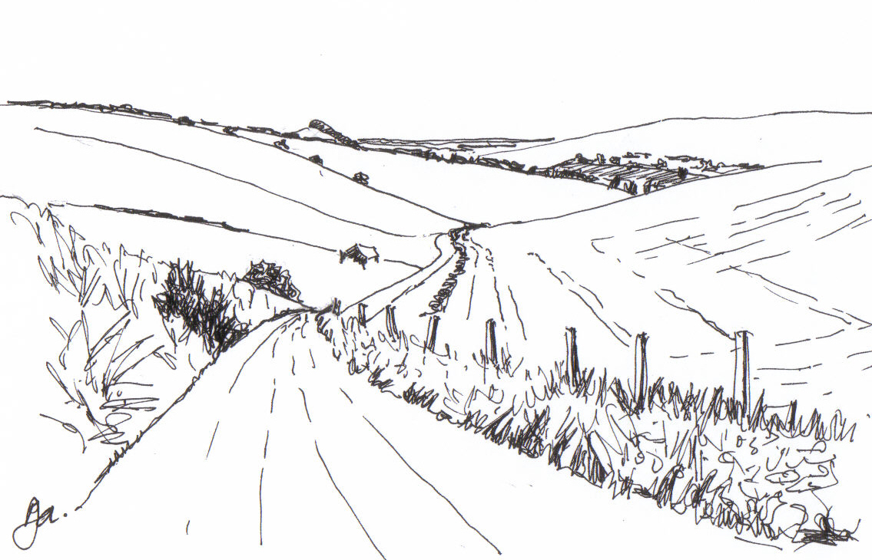

Pen Hill
By
Pat Armstrong
January 2010

Look inside for local information

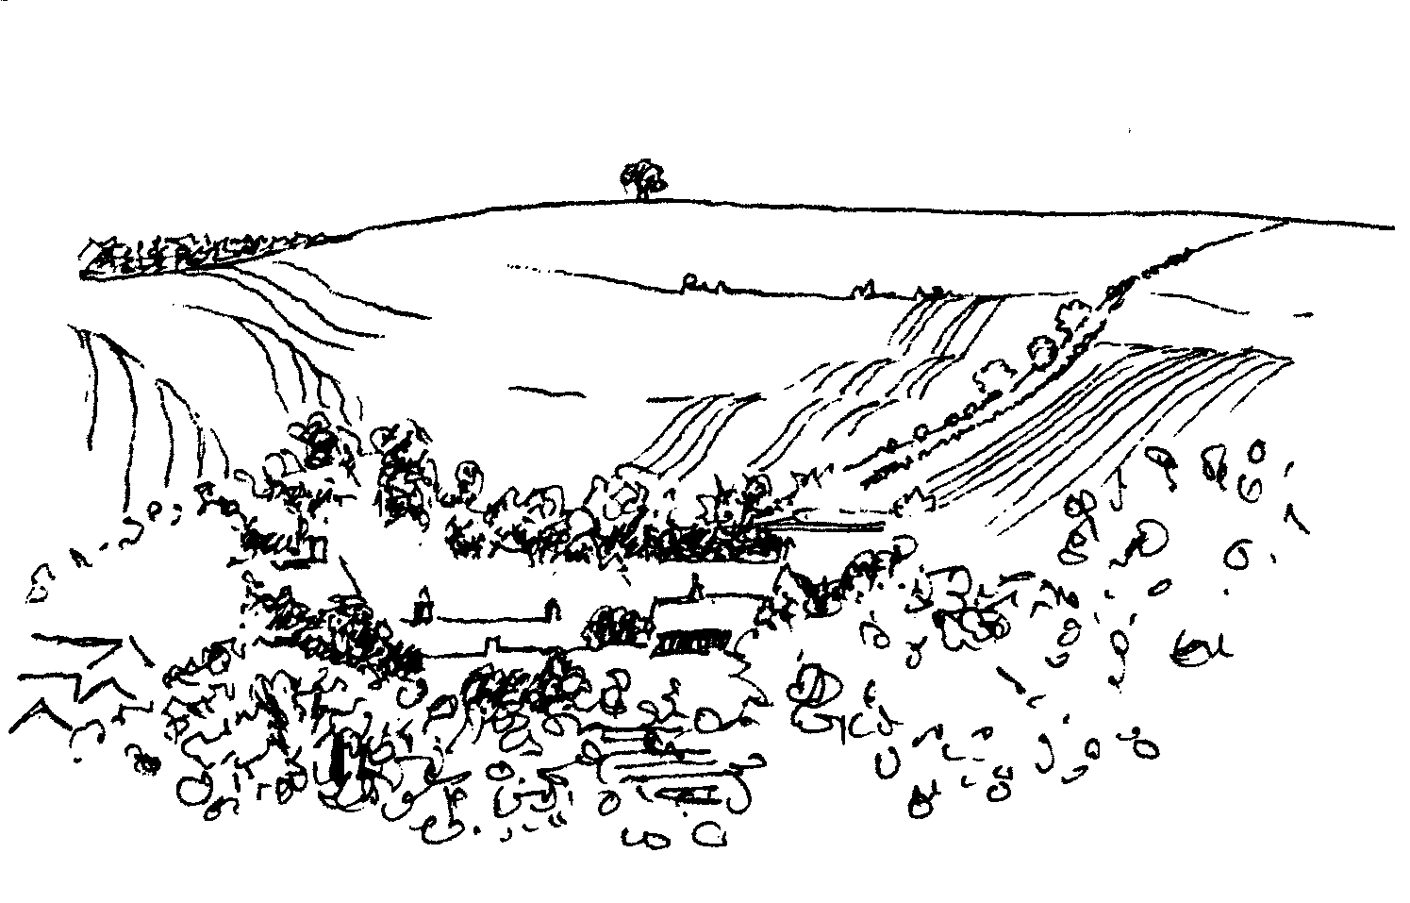
-2-
Longbridge Deverill Village Hall
HAPPY NEW YEAR
BURNS NIGHT
SATURDAY 23RD JANUARY
Four course traditional dinner
7.00 pm for 7.30 pm
Scottish dancing
Please book early, at least a week before the event
Tickets £10 from Sylvia Titt on 214825 or Pat Wood on 840535
Bring your own Wine

Deverill Valley & Crockerton Women's Institute
Longbridge Deverill Hall
Monday 11th January 7.30 pm
Rural India - its people and its wildlife,
by Sarah Buttenshaw
Exhibition ‘Something Indian’
For more information contact Jill Russell 840209

Coffee, Cards and Chat
Come and enjoy looking at the new range of cards,
ribbons, wrapping paper, and other exciting items
displayed by John and Maddie Goodden
in the Upper Deverills Village Hall on Thursday 19th February
between 10.30 and 12.00 noon - everyone is welcome
Donations will be made to the hall and the church

Salisbury Theatre Club Trips
Monday 15th February
Private Lives by Noel Coward
Monday 15th March
The Glass Menagerie by Tennessee Williams
Monday 19th April
Low pay? Don’t pay! by Dario Fo
Monday 17th May
Les Liaisons Dangereuses by Christopher Hampton
The cost is £17.00: theatre seat £12.00 and coach trip £5.00
Please book early to ensure tickets, payment in advance to Mary Stewart Cox
Tel 840877 at Longmead, Brixton Deverill, Warminster BA12 7EJ
Coach leaves Kingston Church 6.10 pm and collects through the Deverills
Performances begin at 7.30 pm

-3-

The Rector writes:
A New Year, a new page
Do you remember how you felt at school when you began to write in a new exercise book? The first page, clean and completely smooth and thoroughly new rested in front of you. What would it eventually look like? Did you, like me, love this new start? There was always a determination to make this the best book ever, containing the neatest and most careful work, something of which to be proud.
I find myself thinking about the start of this New Year in a similar way to starting a new book. What will the year hold ~ for our nation, our communities, our families, for individuals and for our churches? What part will each of us play as the year unfolds? Will there be a determination to make this the best yet? How will we feel about it a year from now as we look back on 2010? What are your hopes for this New Year?
I think it is more positive to think in terms of ‘hope’ than of New Year Resolutions. Hope gives us something to aim for. Hope allows our ideas to develop in the light of changing circumstances. Hope looks forward with anticipation and shapes our actions. So what are your hopes as the year begins? Are you hoping for:
a change in circumstances, peace and political stability across the world, better health, inspired stewardship of the resources of the earth, a greater sense of community, a new relationship, reconciliation?
Speaking personally, I hope that we will be able to learn together, and, in the context of a Diocesan initiative, to come to a deeper understanding of what it means to be ‘Fully Alive’. (This theme was introduced to us in Lent 2009 by Father Timothy Radcliffe.) Discussion groups will take place during Lent, (from Ash Wednesday until Easter). Wherever you are on your faith journey, just beginning or travel weary, sharing the way with others offers encouragement and hope to us all as we learn together. I look forward to interesting conversations on the way.
So I wish you all a Very Happy and Hope-filled New Year.
Norma Payne
§
INTERCESSIONS WORKSHOP: Saturday 23rd January 10.30 to noon
For all who lead prayers or who are interested in doing so,
please put the date in your diary NOW. Details later!
Dr Francesca Elloway (CMS) in Democratic Republic of Congo
Recently a letter arrived from Francesca, to the parish, in which she tells us what has been happening in her area. Sadly one of her midwives, Drazi, has died of cancer leaving her husband with five children to look after. Francesca had been away but arrived back in time to pray with her before she died. Her training in palliative medicine is proving to be extremely helpful but still challenging as using the internet is difficult. Finding good trained staff for Mahagi and Obani hospitals is difficult. More women are coming forward to be HIV tested. However, their husbands tend to leave them if they are found to be positive, without being tested themselves. At home Francesca’s cat has had kittens and the hens she was given have had chicks! She sends everyone her greetings for Christmas and the New Year. A full copy of her letter can be found in Longbridge church.

-4-
Alabaré
These Christian Care Centres were mentioned in the November issue of the Parish News regarding their work with ex-service personnel. They work with many disadvantage groups, the homeless, those at risk of becoming homeless, ex-offenders, people with drug and alcohol issues, young people, vulnerable women, individuals with learning disabilities and people with mental health problems. Through more than forty projects they make a real difference to the lives of people who are socially excluded or disadvantaged.
During the cold winter weather the Alabaré clothing centre in Salisbury is appealing for donations of clean, good quality second hand clothing. These would be much appreciated. If you have any donations you would like to make please call Jackie Moore on 01722 742298 or bring them to church with you on the Sundays in January.
Salisbury Women’s Refuge Profile
Beckingsale House is a large red brick Victorian house on three floors, with an extension that was added in 1990 and a large conservatory built in 1998. The refuge was opened in 1984. It offers space for up to 11 families. Each bedroom is well decorated, has gas central heating, a wash basin and television. Bed linen and towels are provided. There are bathrooms and separate WCs on each floor, including the extension. The large lounge and conservatory are comfortably furnished and overlook the extensive garden, which has a substantial play area for children. The children also have a well equipped playroom. We have a large kitchen in the main house with a smaller one in the extension; both have ovens, microwaves, fridge/freezers. The laundry room has washing machines and tumble driers and airing space.
As a Refuge, Beckingsale House remains unique. It offers a safe haven that is permanently staffed twenty four hours a day, three hundred and sixty five days a year. Residents who arrive with no food or inadequate clothing are immediately supplied with items from our extensive food and clothing stores, all of which have been kindly donated.
Residents are responsible for looking after their children, preparing and buying their food, except when they first arrive, and taking a share of cleaning communal spaces, as well as their own rooms.
The residents can use the services of a designated local solicitor and local medical practice. The children are welcomed into local schools, even on a short term basis. We do not accept male children once they reach fourteen. Each resident is included in a Needs Assessment Plan with the aim of helping her to resume independent living with confidence. The Refuge is very keen on promoting further learning and development and has links to Salisbury College and Learn Direct.
As a refuge we are always looking for support from the community. If you would like to help us, we always need new night wear and underwear for mothers and children, as well as toiletries. Barbara Beilby 844995 will be very happy to arrange collection of donated items which she will deliver to the Refuge.

-5-

Save the Children
Despite horrendous weather conditions, torrential rain and gale force winds, many of our stalwart supporters came along to the Christmas Bazaar on 14th November at Mill Farm House, Hill Deverill, and helped raise £1,405. Heart felt thanks to all who contributed and supported us and a very special ‘Thank you’ to Val Dale and family.
Anne Hurd
Upper Deverills - 30 mph Stickers for Wheelie Bins
As advised in last month's Parish News, the Upper Deverills Parish Council ordered stickers for wheelie bins; forty have now been received for distribution between our three villages. It is hoped another forty will arrive soon. Residents in houses on the routes B3095 in Brixton, Monkton and Kingston Deverill, Hindon Road in Monkton Deverill and Maiden Bradley Road in Kingston Deverill are invited to contact your local councillor if you would like to participate in the scheme. Monkton Deverill - Felicity Wheeler (844683), Brixton Deverill - Robin Greenwood (840743), Kingston Deverill - Sarah Fagan (844123). As numbers are limited at the moment, only one sticker per house can be given whilst stocks last.
On behalf of the Upper Deverills Parish Council may I wish everyone a Happy New Year. Our next meeting will be Wednesday 6th January at 7.00 pm - please note the earlier start time. All are welcome to attend.
Lady Felicity Wheeler - Chair
Longbridge Deverill & Crockerton Parish Council
Further to the article by the Upper Deverills Council in December, we have now taken delivery of 30 mph wheelie bin stickers. If anyone living in a 30 mph area would like one (or two, one for each side,) please contact the Clerk on 840119 or let any of the Councillors know. A whole street of these, in Clay Street Crockerton for example, may just jog people’s minds once a fortnight of the need to slow down.
We are also looking for 8-10 volunteers to join the Community Speed Watch Scheme and have training on using the speed guns. This is especially aimed at Clay Street in Crockerton, so if you live in this area please contact Karen Manfield, Parish Council Chairman, on 215526. Anyone living in other areas of Crockerton or Longbridge Deverill are very welcome to join the team, hopefully we will be able to cover Sand Street in Longbridge as well. We look forward to hearing from as many volunteers as possible, as soon as possible, so that this scheme that the Council have fought to be a part of can go ahead in the New Year.
On behalf of all the Councillors, I wish everyone a ‘Happy New Year’. We look forward to seeing you at our next meeting on Monday 4th January at 7.30 pm.
Karen Few - Clerk
Happy New Year
To everyone who lives in our villages. Thank you to those who have sent me articles and information during the past year for our Parish News. I appreciate everything you give me and I am always pleased to hear from you. I hope 2010 will be a very happy and healthy year for all the residents who live in our beautiful valley.
Judy Munro - Editor

-6-

Your Parish News - Donations and Subscriptions
Thank you to those who generously donated boxes of paper for printing the Parish News during the year, these really help to keep production costs down, and we would be very grateful for further donations in 2010. As usual in January we are asking for the annual subscription of at least £5 per household. Your contribution is vital to ensure the continuation of our Parish News which helps to keep our community informed of news and events within and outside our area, and other important information. Please use the enclosed pale blue envelope for your donation and if you are a UK tax payer complete the sections so that we can reclaim the tax. Some financial support is also received from the PCC and other Parish Organisations. Thank you. The envelopes can either be:
Put into the collection at Church or given to a Church Warden
Given or sent to David Stratton, PCC Treasurer, Manor Farm, Kingston Deverill
Put into the collecting box on the counter at Longbridge Post Office
Sent or given to Judy Munro, Whitepits Lodge, Kingston Deverill
A special thank you to all who help to produce and deliver the Parish News.
Judy Munro - Editor
Good wishes from Crockerton School
It is that time of year again, when from a school perspective we have completed the first terms of the new school year, our new children to the school are settling in and making friendships, and everyone has enjoyed a good break over the Christmas period. On behalf of the staff, governors, and children at the school I would like to take this opportunity to thank all the residents of the village for their support in 2009, especially during the installation of the new mobile. We hope you have had a peaceful and fulfilling seasonal holiday and wish you a happy new year.
Graham Dopheide - Chair of Governors
Pre-School Children and Parent Thursday Group
The group will reopen at 10.00 am on Thursday 14th January, when we hope to welcome our regular and new families at Longbridge Deverill Village Hall. For more details contact Barbara Beilby 844995.
The Cast on Club
Thank you to those who have come to the previous meetings. This month we meet on Thursdays 7th January and 21st January from 10.30 am - 12.30 pm at Dinah Barnes’s house, The Old Chapel, Kingston Deverill. Everyone is welcome whatever your knitting skills! The patterns are simple. Please bring some soft baby wool and a pair of 8 or 9 needles. Contact Dinah 844117 if you need directions.
Tennis Coaching
A group of ‘girls’ meet at the Warminster courts at 9.30 am on Tuesdays for coaching. If you are interested in joining us please contact Judith Hirons 845255.

-7-
Upper Deverills Village Hall
Bill’s Music Evening Friday 22nd January 7.30 pm
Bill Knowles will offer his usual eclectic mix of music for appreciation in the Village Hall. Bread and Cheese will be offered in the interval but those attending are invited to bring their own liquid refreshment. Come and enjoy an entertaining and relaxing evening.
Dates of Main events in 2010
Friday 22nd January Bill’s Music Evening
Friday 5th February Film Night
Saturday 17th April Indian Curry Night
Friday 18th June Rounders Evening
Saturday 3rd July Duck Race
Saturday 17th July Summer Fete
Friday 1st October Film Night
Saturday 16th October Harvest Supper
Friday 12th November Quiz Night
Sunday 14th November (Remembrance Sunday) Curry Lunch
Sunday 19th December Carol Service
Richard Cousens - Chairman
Longbridge Deverill Village Hall
A packed house, with every seat taken, enjoyed a Christmas Musical Get Together at the hall. The entertainment ranged from traditional carols and choirs to humorous Christmas tales. It was marvellous to see so many people from the parish and beyond supporting this annual event. My thanks to all who took part, to Janet and John Budgen for helping to coordinate the programme and to the ladies of the committee for supplying the delicious refreshments. See you all same time, same place next year!
Julie Read Chairman
NB Burns Night on Saturday 23rd January - see page 2 for details.
Heatstroke to Frostbite
Saturday 6th February in Longbridge Deverill Village Hall
The doors will open at 6.45 pm for a glass of wine and the talk will be at 7.00 pm followed by supper. Information and tickets (£12) from Nigel and Marie Poole 840902 or David and Peggy Prior 216904. Reserve this evening for a fascinating talk by Chris Todd about his experiences in the Gobi Challenge of July 2008 and the ultimate challenge ‘6633’ in March 2009. The Gobi Challenge was to complete 150 miles in 6 days, almost a marathon a day in temperatures of +40C. The 6633, named because it starts on the Arctic Circle at 66 degrees 33 minutes north, was 350 miles in 7½ days with temperatures down to -40C. From a large international start list, Chris was the only person to finish this race. Chris completed these challenges to raise money for the Wiltshire Blind Association. The talk and supper will help raise money to support an adventure weekend in Scotland for a group of the Wiltshire blind so that they can experience the thrills of canoeing, abseiling, climbing and fell walking.

-8-

The Deverills & Horningsham Register
Funeral and Burial at Horningsham
Albert Compton on Thursday 10th December
SERVICES PARISH OF DEVERILLS & HORNINGSHAM
Sunday Epiphany
3rd January Brixton 8.00 am Holy Communion 1662
Longbridge 10.30 am Morning Worship
Horningsham 11.15 am Holy Communion
Sunday Baptism of Christ
10th January Kingston 10.30 am Holy Communion
Horningsham 6.30 pm Plough Sunday Service
Sunday Epiphany 2
17th January Longbridge 8.00 am Holy Communion 1662
Horningsham Chapel 10.00 am Prayer for Christian Unity
Brixton 10.30 am Holy Communion
Sunday Epiphany 3
24th January Longbridge 10.30 am Holy Communion
Horningsham 11.15 am Morning Prayer
Sunday Presentation of Christ
31st January Corsley 10.30 am Benefice Service
Sunday 2nd Sunday before Lent
7th February Kingston 8.00 am Holy Communion 1662
Longbridge 10.30 am Morning Worship
Horningsham 4.00 pm Evensong

Tuesday, Wednesday, Thursday, Friday Longbridge 8.30 am Prayers
Wednesday Longbridge 10.15 am Holy Communion

Parish Prayer Group meeting - Deverills and Horningsham
Tuesday 5th January 7.00 pm to 8.00 pm Mary Royall’s house (840338)

Contact the Clergy
Please contact Norma Payne (841321) or Di Britten (01373 832515) if anyone is housebound and would like communion or a visit at home;
or if someone is ill and needs our prayers; or to discuss any church matter.
Office administrator phone 210149 or email: office@cleyhill-team.org.uk

The Deverills & Horningsham Register
Funeral and Burial at Horningsham
Albert Compton on Thursday 10th December

Contact the Clergy
Please contact Norma Payne (841321) or Di Britten (01373 832515) if anyone is housebound and would like communion or a visit at home;
or if someone is ill and needs our prayers; or to discuss any church matter.
Office administrator phone 210149 or email: office@cleyhill-team.org.uk

-9-

SERVICES PARISH OF CORSLEY & CHAPMANSLADE
Sunday Epiphany
3rd January Corsley 9.00 am Holy Communion
Sunday Baptism of Christ
10th January Chapmanslade 9.00 am Holy Communion
Temple 11.00 am Morning Prayer
Sunday Epiphany 2
17th January Chapmanslade 9.00 am Holy Communion
Corsley 4.00 pm Holy Communion
Sunday Epiphany 3
24th January Temple 9.00 am Holy Communion 1662
Corsley 10.30 am Parish Service
Sunday Presentation of Christ
31st January Corsley 10.30 am Benefice Service
Sunday 2nd Sunday before Lent
7th February Corsley 9.00 am Holy Communion

Ivy House St Denys Retreat Centre
For booking & information please ring 214824
Thursday 7th January - House Quiet Day
Canon Christopher Brown

Church Cleaners for January
Kingston - Mrs Munro & Mrs Fagan
Brixton - Mrs Marsh & Mrs Greenwood
Longbridge - Monday 11th January 9.30 - 10.30 am - all helpers
Church Flower Arrangers for January
 | Kingston | Brixton | Longbridge
3rd Jan | Mrs Stratton | Mrs Marsh | Mrs Steptoe
10th Jan | Mrs Beilby | Mrs Marsh | Mrs Scott
17 Jan | Mrs Beilby | Mrs Burridge | Mrs Scott
24 Jan | Mrs Noonan | Mrs Burridge | Mrs Hinton
31st Jan | Mrs Noonan | Lady Walker | Mrs Hinton

-10-
MAIDEN BRADLEY PANTOMIME
Robin Hood of Bradley Wood
Thursday 14th, Friday 15th and Saturday 16th January
Maiden Bradley Village Hall
Doors open 7.00 pm - curtain up 7.30 pm
Tickets £6.00 (£4.00 concession) from Maiden Bradley Shop
Come along and enjoy an evening of music, fun and laughter
For further information please call 844745

Recipe of the Month
Sponsored by Maiden Bradley Community Shop (844206)
Florentines - makes 18 - from Rosie Brown
Pre heat the oven to 180C (350F) 2 oz (50g) blanched almonds
2 oz (50g) candied orange peel or mixed peel 1 oz (25g) sultanas
1½ oz (40g) glacè cherries 1½ oz (40g) butter
½ oz (15g) candied angelica 1 level tablespoon sieved plain flour
2 oz (50g) caster sugar 1 teaspoon lemon juice
1 tablespoon double cream Non-stick baking paper
6 oz (175g) plain desert chocolate
Method
- Line 3 or 4 baking sheets with non-stick paper.
- Dice the orange peel or mixed peel finely, cut the almonds into narrow slivers.
- Halve and finely slice the cherries.
- Chop the sultanas and angelica.
- Mix all these ingredients in a bowl.
- Melt butter in pan over low heat, beat in flour, cream, lemon juice, stir in nuts, fruit.
- Place rounded teaspoons of mixture 2 inches (50mm) apart on lined baking sheets.
- Place in centre of pre-heated oven for 10-15 minutes until golden brown.
- Leave on baking paper until cold, carefully peel away, place upside down on wrack.
- Break chocolate into small pieces and melt in bowl over hot water.
- Spread thin layer of chocolate on smooth side of biscuit with small palette knife.
- When half set drag fork across the chocolate in a zig-zag pattern.
Leave to cool and set completely.
Fund raising evening for Maiden Bradley Community Shop
The evening will be held in Bradley House on Saturday 30th January at 6.30 pm. There will be an illustrated slide show accompanied by Richard Trehain reading from Elizabeth Dineley’s book entitle ‘A Year in a Day’. This combination has given many successful shows featuring the Wiltshire countryside. The ‘show’ will last for about two hours and include a break for a glass of wine and nibbles. Afterwards there will be a finger buffet, also included in the price. A pay bar will be open for the buffet. Most of the ground floor of Bradley House will be available to circulate in. Tickets will be £15.00 per person and on sale in the shop from 5th January. We hope to see you there.

-11-
Fairtrade Mark

In 1994, the first products bearing the Fairtrade mark hit the shelves in the UK, Green & Black’s Maya Gold chocolate, Cafédirect medium roast coffee and three varieties of Clipper tea. Thanks to its supporters, the Fairtrade movement has gone from strength to strength; today shoppers can choose from more than 4,500 Fairtrade certified products. Here are 15 facts about Fairtrade:
- Celebrations: The Fairtade mark is 15 years old.
- Off the shelf: The first three Fairtrade products appeared on shop shelves in 1994 - now more than 4,500 products have been licensed to carry the Fairtrade mark, including sugar, grapes, mangoes, avocados, dried fruit, cakes, jams, rice, herbs & spices, wines, beers, ice-cream, flowers, sports balls, clothing, homeware, Palestinian olive oil and cosmetics.
- Spending the premium: The Fairtrade premium, which is an additional sum for community development, is used by farmers’ groups for many projects, eg. building schools and medical clinics, providing clean drinking water, piloting organic conversion schemes to help farmers work for the future.
- Recognition: A massive 72% of the UK public now recognize the Fairtrade mark (TNS September 2009).
- Fairer future: More than 7 million people in Africa, Asia and Latin America benefit from Fairtrade - farmers, farm workers, and their families.
- Good business: Growers at the heart of the Cafédirect business have shares in the company, and sit on the Board and are part of the decision-making process.
- Do the maths: If 15 people recruit 15 friends and relatives to the Fairtrade movement this month, then they each recruited 15 people, then they each recruited 15 people, that would make 50,625 new Fairtrade supporters.
- Tea: The first tea products carrying the Fairtrade mark were Clipper Sri Lanka Golden, Clipper Nilgiri Blue Mountain and Clipper Earl Grey Nilgiri.
- Top towns: The first Fairtrade town was Garstang in 2000. Now there are more than 450 towns. There are 100 Fairtrade Universities, 3,000 schools, 5,000 Fairtrade Churches, 40 Fairtrade Synagogues and one Mosque.
- Global appeal: In 1994, the first Fairtrade certified products came from Belize, India, Costa Rica, now Fairtrade products come from 58 developing countries.
- Chocoholic: One of the first Fairtrade certified producers, cocoa farmer Justino Peck, from Toledo Cacao Growers Association, a farmers’ cooperative in southern Belize, still sells his Fairtrade cocoa to Green & Black’s.
- Going bananas: Since launching in 2000, Fairtrade bananas now account for 1 in 4 bananas sold in the UK.
- Family matters: Consumers are spending more on Fairtrade with the average increasing by 5.5% this year. Sales of Fairtrade are also increasing reaching an estimated £700m in 2008, a 43% increase on the previous year.
- Looking ahead: Fairtrade Fortnight 2010 will be held from 22nd February – 7th March, and is expected to be the biggest celebration of Fairtrade so far.
- Fantastic fabric: Since the introduction of Fairtrade certified cotton in 2005, annual sales have risen from a humble 200,000 to 7.79 million in 2008.

-12-
Link Scheme celebrating 30 years
It was formed to serve communities in Wiltshire in 1979 when Dr John McQuitty, a GP from Box, recognised the need for a volunteer based good neighbour service in his area. From identifying this need for a ‘holistic’ approach to caring and supporting those most vulnerable in his community, the blueprint for all Link Schemes in Wiltshire was created. We celebrate the 30th Anniversary of Box, Colerne and Rudloe Link Scheme. Without the scheme those in need within communities would be made more vulnerable, isolated and excluded from things the rest of us take for granted. The scheme’s volunteers are its greatest natural resource. 1,500 volunteers enjoy volunteering for Link, helping people to get to vital services such as doctors and dentist appointments, taking them shopping, visiting an old friend, or simply providing good neighbour care. These essential and valuable schemes also offer free and confidential assistance with other tasks that often allow people to continue living an independent lifestyle adding to their quality of life. The Scheme aims to complement the provision of other services, statutory or voluntary. This all helps the clients and volunteers to remain connected to their communities. Today, with a coverage of 98% of all rural Wiltshire, the Link Schemes help about 900 people a week and travel almost 16,000 miles a week. Each Link Scheme is run by a group of local volunteers managed by a local Link Co-ordinator. Users wishing to use the scheme call their local co-ordinator who will then arrange for a volunteer to carry out the task. The Link Scheme Project, based at Community First, provides support and advice to communities wishing to set up a local volunteer Link Scheme, then ongoing support and training for established schemes. There are 43 Link Schemes established in Wiltshire & Swindon giving Good Neighbour support for those in need in rural communities. If you would like more information or to find out how to become a volunteer contact Marion Mason on 01380 722241.
Neighbourhood Watch

Hare coursers have been very active lately in Codford and Chitterne and the Deverill areas. If you see any vehicles on farmland which you are suspicious about, particularly late evening or early morning please note the registration number and call 0845 408 7000.
Immobilise is a free online possession and asset ownership registration service which can be used by the general public. You can register at www.immobilise.com; it will take no more than 5 minutes to set up your account. You can register as many items as you wish, free of charge. Items are registered by make, model and serial number and in the case of mobile phones, the IMEI number which is obtainable by keying in *#06# on the phone keypad. In the event of loss, theft or disaster all the information relating to possessions is available by logging onto the site, a printable certificate can be obtained to assist insurance claims. This is hugely valuable to assist in reporting information accurately to police and insurance companies. It is easy to add, delete or edit property entries, photographs can also be included. If your registered property is recovered, either the police or immobilise will contact you.
Ian Owen Police Community Support Officer

-13-
Nature Notes
Just after I had written the article for last month, when I went for my walk in the morning, I found that a limb of one of our old beech trees had come down. As I approached I realized that it was the limb where we have a bee colony. I went a little closer and could see that the colony was quite exposed with comb visible and that the bees were very agitated. We asked a bee keeper friend of ours to take a look to see what could be done to help the situation. He came later that morning and his advice was to leave the colony in situ for now, maybe rescue them in the spring, but he could see that they had plenty of food and the only concern was to protect them from the weather, particularly the wet. So he managed to cover the limb where the colony is with polythene tied down tightly with bailer twine. By the following morning the bees had settled quite nicely and were finding the new way in and out which had been left for them. I check them regularly, and about 10 days later, after a very wild and windy night, I found a second larger limb of the same tree had come down grazing the first limb where the bee colony sits. Luckily the colony hadn’t been disturbed and as I write this they still seem to be all right. They are deep in the trunk huddling to keep warm with plenty of food to see them through the winter.
Colder weather is forecast for the end of this week and this will surely increase the consumption of bird food; just as well I have ordered more. The next few months are the most difficult for the birds as the autumn harvest that nature provides is used up and the warmth of spring is still a way off. The hours of daylight are so short as well which compounds the difficulty in finding food. January and February are often the busiest months at the bird feeders and you can get really good close-up views of the increased species visiting and in greater numbers, especially if you provide a variety of food. Already we are getting coal tits back on our feeders, and long-tailed tits have found the peanuts and fat balls. The numbers of goldfinches visiting continues to rise, with a dozen at a time the norm. Out in the fields the flocks of fieldfares and redwings are growing in size and are often accompanied by starlings. Bramblings and maybe even waxwings may visit our shores over the next few months, so it is worth taking a second look at the flock of chaffinches just in case there are some bramblings in amongst them. Check the birds feeding on the berries in the supermarket car park as they could be waxwings.
Most days when I go for a walk up the track round the back of the farm I see deer in the field of stubble turnips. Sometimes it is only ‘the family of three’, other days I count six or seven. When I was returning down the track from my walk one day recently something brown shot out from the stubble turnips some distance in front of me, I was expecting it to be a deer. But no, it was a fox, and judging by its behaviour a youngster, as when it saw me it stopped, held its tail in the air and ‘danced’ off across the field, just like a puppy playing, through the sheep, who were not a bit bothered, and disappeared into the lane. I have not seen a fox in broad daylight for some time, although I have been hearing the vixen calling at night recently, a sound that will be often heard over the next month or so as she seeks a mate.
Jane Trollope (written on 14th December)

-14-
LOCAL COUNCILS, SOCIETIES, GROUPS etc.
Longbridge Deverill and Crockerton Parish Council
Karen Manfield 215526 (Chair) Peter Whithey 840347 (Vice Chair)
Helen Few 840119 (Clerk) Thomas Minter 216909
Bill Hurd 840023 Elaine Pidgeon 212878
Julian Algar 840816 Graham Read 840296
Brian Marshall 214789
Upper Deverills Parish Council
Lady Felicity Wheeler 844683 (Chair) Ranald Blue 841374
Sarah Jeffries 213436 (Clerk) Patricia Shuler 844291
Sarah Fagan 844123 Robin Greenwood 840743
Wiltshire Councillor
Fleur de Rhé Philipe 213193

Wiltshire Council 0300 456 0100

Longbridge Deverill Village Hall Committee
Julie Read 840655 (Chair) Sylvia Titt 214825 (Caretaker)

Upper Deverills Village Hall
Richard Cousens 844970 (Chair)
Mandy Martyn 844320 (Secretary) John Lea 844325 (Hall bookings)

Crockerton Millennium Committee
Marion Thomas 213739 (Chair)

Pre-School Children and Parents ‘Thursday Group’
Barbara Beilby 844995 (Chair) Sylvia Titt 214825 (Leader)

Deverill Valley & Crockerton W I
Ruth Sutton (President) Jill Russell 840209 (Secretary)

Sir James Thynne Almshouse
Mrs Sue Jackson 840322 (Steward)

Deverills Cricket Club
Jamie Fagan 844123 Peter Child 01963 34593

Wylye Valley Tennis Club
Colin Singer 213696

Wylye Valley Flower Club
Mrs Hazel Yate 215617 (President) Mrs S Scott 213689 (Programme Secretary)

Wiltshire Wildlife Trust
Elm Tree Court, Long Street, Devizes SN10 1NJ www.wiltshirewildlife.org

Rural Community Beat Manager - Police Community Support Officers
PC Vicky Pegrum - PCSOs Ian Owen & Caroline Wright - 0845 408 7000

Hospital Transport Link Scheme 211655

-15-

F O R T H C O M I N G E V E N T S
Forthcoming Events

- Scottish Dancing Monday Evenings Aline Fry (841054)
- Bell Ringing at Longbridge Wednesdays 7.30 pm Richard Munro (844385)
- Hearing Loss Lip-reading Wednesdays Margaret Head (213259)
- Pre-school & Parents Group Thursdays 10.00 - 11.30 am See p14
- Deverills Chamber Choir Fridays 7.30 pm Claire Johnson (01373 836012)
- Longbridge & Crockerton Parish Council meeting 7.30 pm Monday 4th January at Longbridge Village Hall See p5/14
- Parish Prayer Group Tuesday 5th January See p8
- Upper Deverills Parish Council meeting 7.00 pm Wednesday 6th January at
Upper Deverills Village Hall See 5/14
- Ivy House Quiet Day Thursday 7th January See p9
- Cast on Club Thursday 7th & 21st January See p6
- WI Meeting Monday 11th January See p2
- Wylye Valley Flower Club ‘Practice Evening’ Tuesday 12th January See p14
- Thursday Group reopens Thursday 14th January See p6/14
- Robin Hood of Bradley Wood Pantomime 14th, 15th, 16th January See p 10
- Bill’s Music Evening Friday 22nd January See p7
- Intercessions Workshop Saturday 23rd January See p3
- Burns Night Saturday 23rd January See p2/7
- Presentation in Bradley House Saturday 30th January See p10
- Upper Deverills Film Night Friday 5th February See p7
- Heatstroke to Frostbite Saturday 6th February See p7
- Salisbury Theatre Club Monday 15th February See p2
- Salisbury Theatre Club Monday 15th March See p2
- Indian Curry Night Saturday 17th April See p7
- Salisbury Theatre Club Monday 19th April See p2

F O R T H C O M I N G E V E N T S
16-
PARISH OF DEVERILLS AND HORNINGSHAM
Contact the Editor and the Website

Parish News Editor: Judy Munro 844385
Contributions for the Parish News through my letterbox or
by post to Whitepits Lodge, Kingston Deverill, Warminster,
BA12 7HD or by Email: judymunro@tiscali.co.uk Thank you
Please remember the deadline is the 15th of every month

Website: www.deverills.org.uk
Email address: info@deverills.org.uk
Website manager: Kate Wilkinson 844998
Contents: Parish News with church services, Parish Register, Events,
Local news plus pictures and other information
Churches
SS Peter & Paul the Apostles Longbridge Deverill
St Michael the Archangel Brixton Deverill
St Mary the Virgin Kingston Deverill
St John the Baptist Horningsham
Rector
Rev Norma Payne, 6 Homefields, Longbridge Deverill 841321
Clergy
Rev Diana Britten, 69 Lane End, Corsley 01373 832515
Licensed Lay Ministers
Mr John Budgen 218203
Col Robin Chappell 212153
Churchwardens
Mrs Elisabeth Atkinson (Longbridge Deverill) 212129
Mrs Mary Stewart Cox (Brixton Deverill) 840877
Major Mike Tulloch (Kingston Deverill) 844381
Mr Tim Moore (Horningsham) 844336
PCC Treasurer Mr David Stratton 844549
PCC Secretary Mr Nigel Poole 840902
Church Electoral Roll Officer Major Mike Tulloch 844381
Parish News Editor Mrs Judy Munro 844385
Organist Mr John Budgen 218203
Bell Tower Captain - Longbridge Mr Steven Young 212796
Caretaker - Longbridge Church Mrs Sylvia Titt 214825
Office Administrator Mr Dick Collins 210149
(Mon -Thurs 10.00 - 12.00) 22 Church Street, Warminster

